December 2010 Once Upon A Star - We Bring The Party To You!

Sunday | Monday | Tuesday | Wednesday | Thursday | Friday | Saturday
Book our Mrs. Claus for your Holiday Party! |  |  | 1 | 2 | 3 | 4
5 | 6  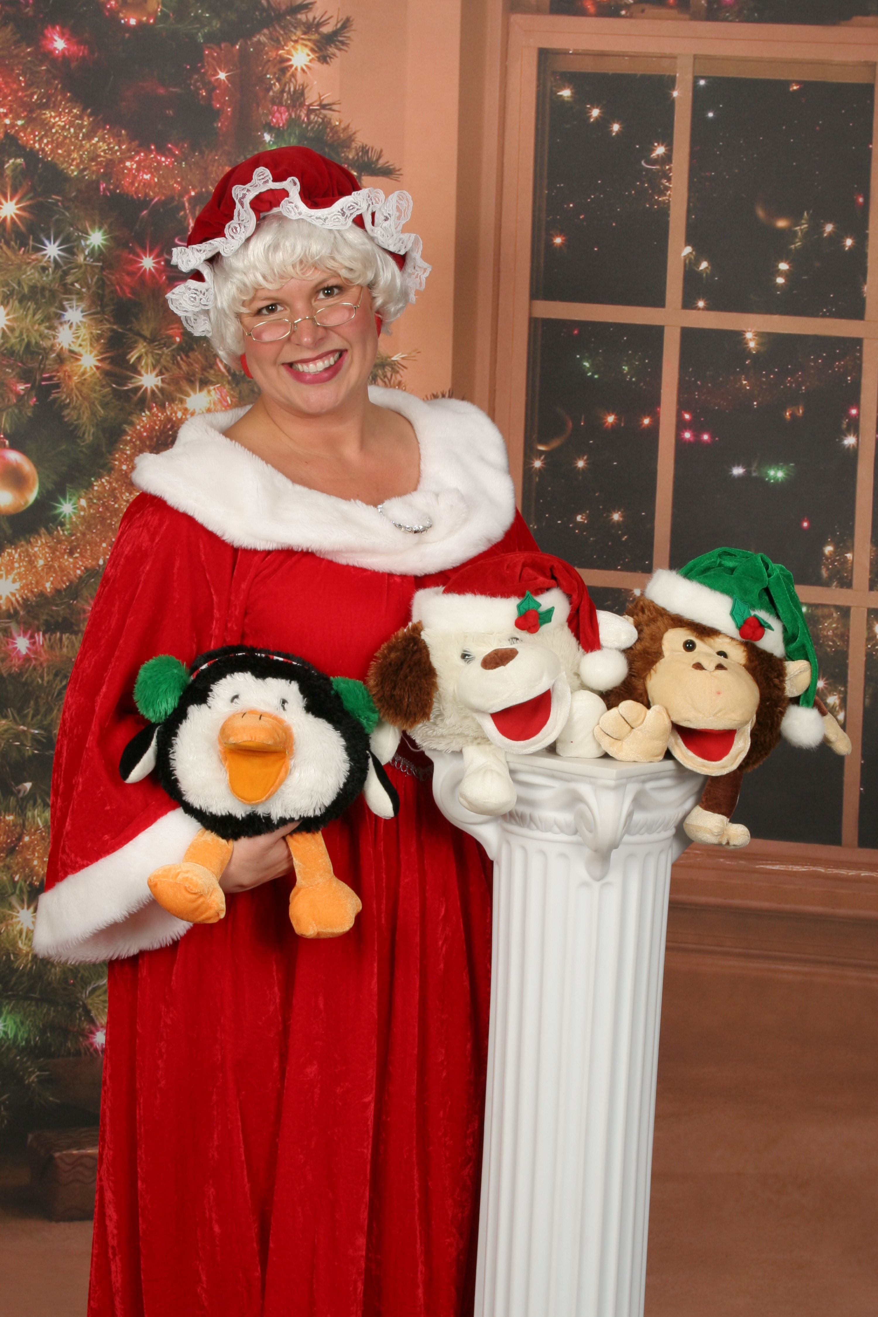 | 7 | 8 | 9 | 10 | 11
12 | 13 | 14 | 15 | 16 | 17 | 18
19 | 20  HAPPY HOLIDAYS FROM THE  ONCE UPON A STAR TEAM! | 21 | 22 | 23 | 24 | 
26 | 27 | 28 | 29 | 30 | 31

